Design Document: TIA Portal Multiuser Project Octoplant Checkin EXE

1. Use Case:

The system continuously monitors the TIA Portal Project Server for new project revisions and automatically imports them into Octoplant without requiring manual intervention. It runs in the background to ensure all project versions remain synchronized and securely version-controlled. After each successful check-in, the corresponding component is automatically locked to prevent check-in by other users.

2. Process Flow
- The overall workflow is as follows:
- User provides Octoplant credentials, directory path, server name, URL , server project and local Octoplant installation directory.
- The system connects to the Project Server using the specified Server URL.
- The latest version of the chosen project is automatically exported from the server to a workspace.
- Using the provided Octoplant credentials, the system performs a Check-In operation on the exported project via CLI.
- Upon successful Check-In, the related project component is automatically locked to prevent parallel modifications.

3. Modules

General Configuration
Stores user credentials, domain, DB folder, and operational parameters in encrypted JSON.

Server Management
Handles addition, modification, and deletion of project servers and URLs.

Project Management
Maps projects to users and servers, supporting CRUD operations with component linkage.

JSON Storage
Provides centralized encryption, decryption, load, and save methods for configuration persistence.

Reference Documents Link :
- Export server projects and server libraries • Using Team Engineering • Reader • TIA Portal Informat…
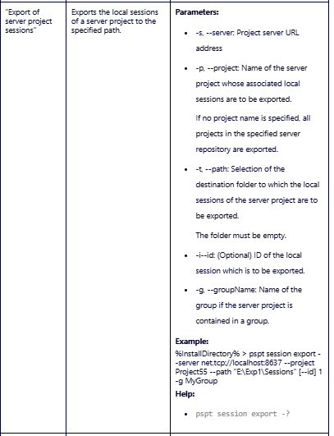
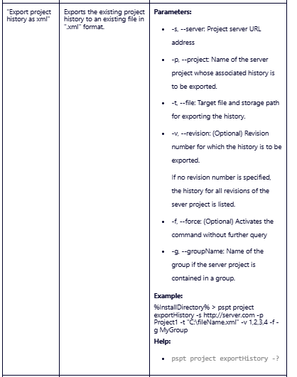
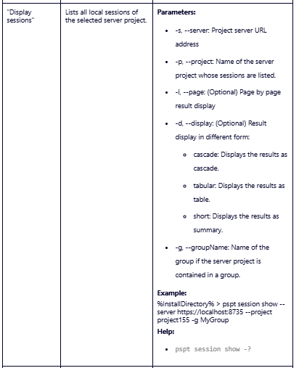
4. Flowchart:

5. Key Methods with Code and Output

EncryptString()
Code:
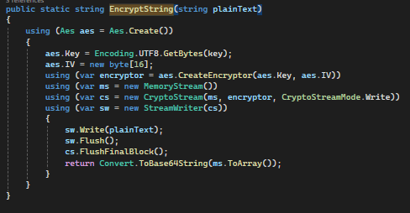
Description: Encrypts plain text using AES encryption. Used to secure Octoplant passwords in the JSON file.

DecryptString()
Code:
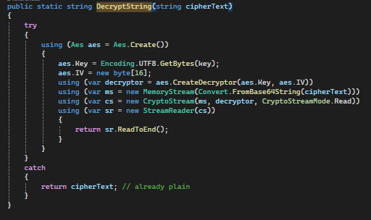 Description: Decrypts AES-encrypted strings when configurations are loaded from the JSON file.

TIA Portal Project Server Importer Configuration :
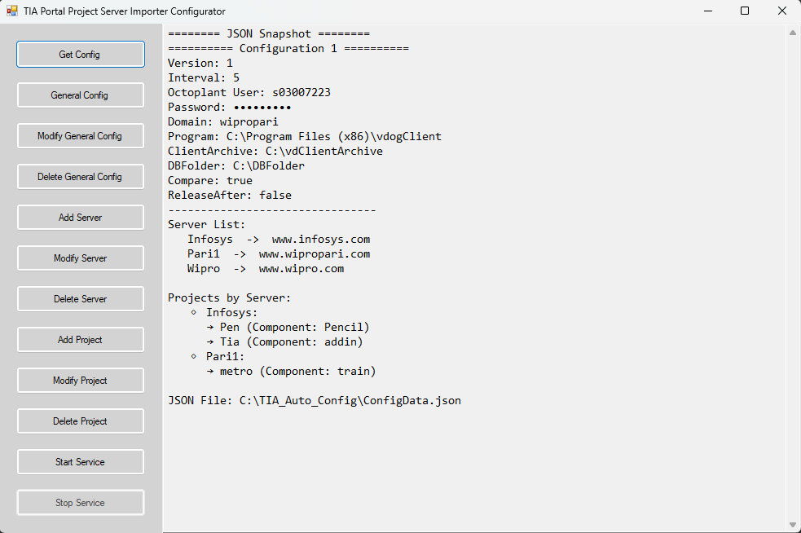

ConfigData.json File : Stores All Data in JSON format.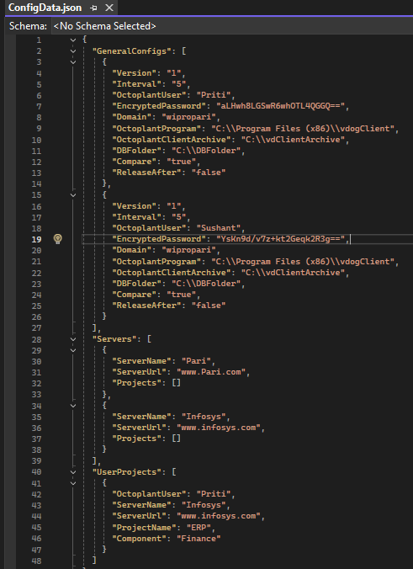

AddOrUpdateGeneralConfig()
Code:
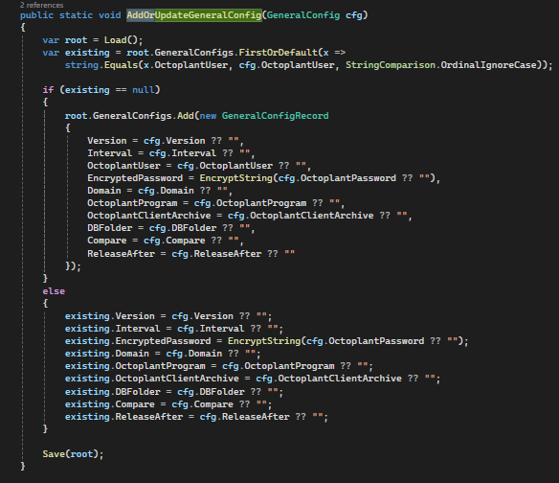Description: Adds or updates a General Configuration entry. Ensures encrypted password storage and proper JSON serialization.
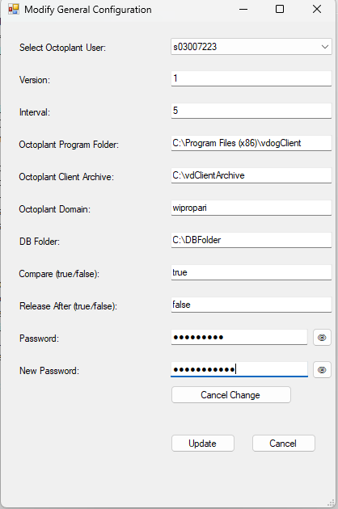
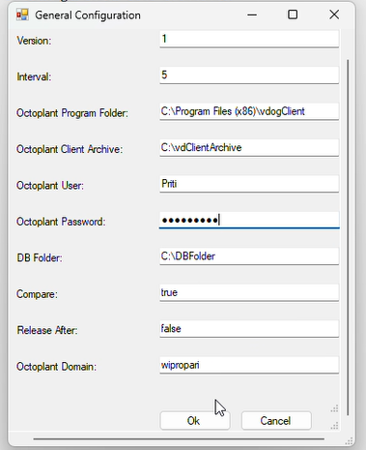
Result :

AddOrUpdateServer()
Code:

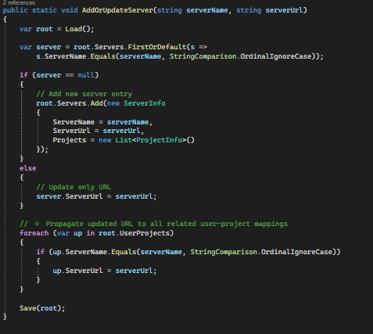
Description:This method adds a new server entry or updates an existing server’s URL in the configuration file.If the specified server does not exist, it creates a new record with an empty project list.If it already exists, the method updates its URL and propagates the new URL to all related user–project mappings before saving the changes to JSON.
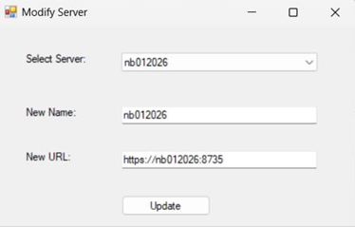
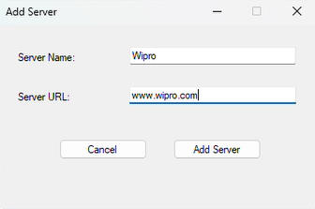
Result :

DeleteServer()
Code : 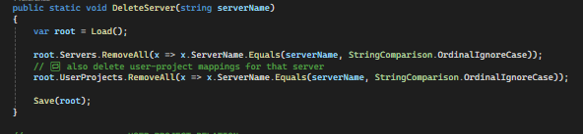
Description:This method removes a server entry from the configuration file based on the provided server name.It deletes the server record from the server list and also removes all associated user–project mappings linked to that server to maintain data consistency.Finally, it saves the updated configuration back to the JSON file.
Result :
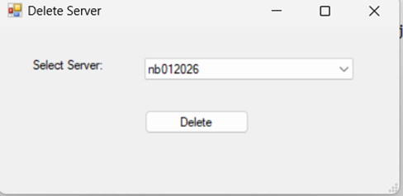

AddUserProject()
Code:
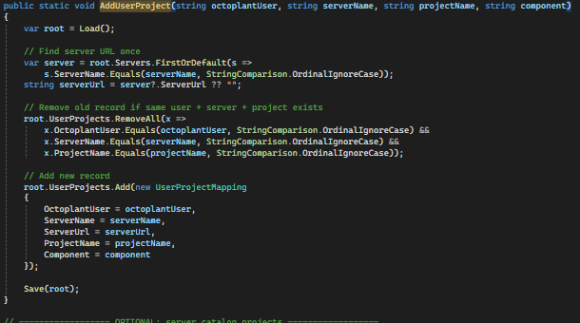
Description: Links a project with a specific Octoplant user and server. Updates the mapping in JSON storage.
Result :
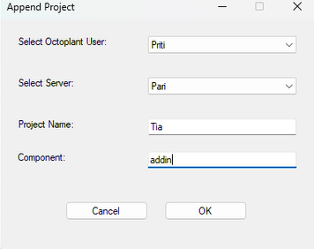

AddorUpdateProject()
Code:
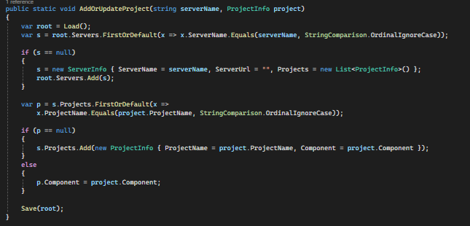
Description:This method adds or updates a project entry under a specific server in the configuration.If the server doesn’t exist, it creates a new one.If the project already exists under that server, it updates its component information; otherwise, it adds the project as a new entry.
Result :
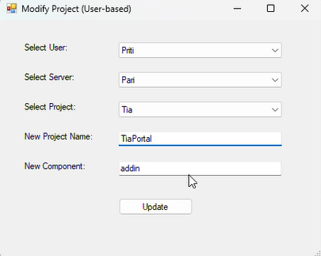

DeleteProject()
Code:
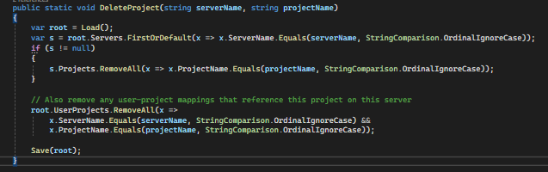
Description:This method deletes a specific project from the given server in the configuration.It first removes the project entry from the server’s project list, then removes any related user–project mappings referencing that project on the same server, and finally saves the updated data back to the JSON file.
Result :
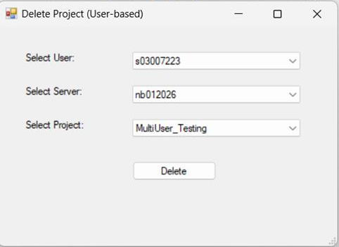

BtnStartService_Click()
Code:
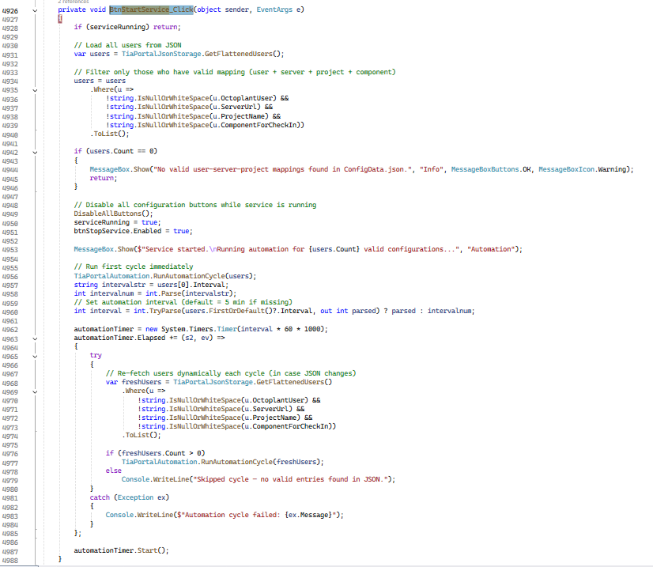
Description : This method check the input data if the data and sort the complete data those have all parameters check the interval time and call the RunAutomationCycle() method and pass the user data, in this it recursively call this method based on time interval to perform the task repeatedly.

Button for start service:


RunAutomationCycle()
Code:
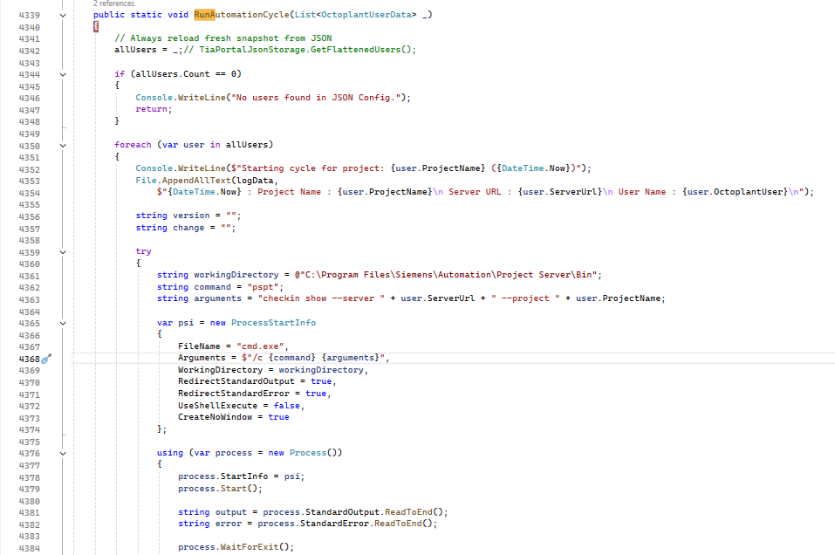
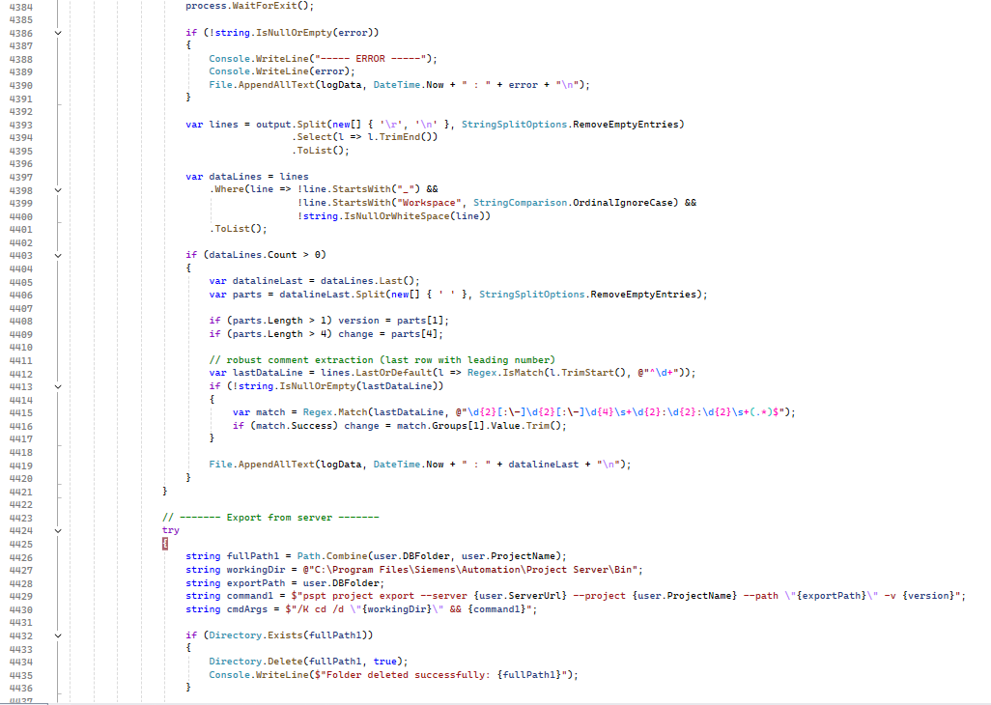
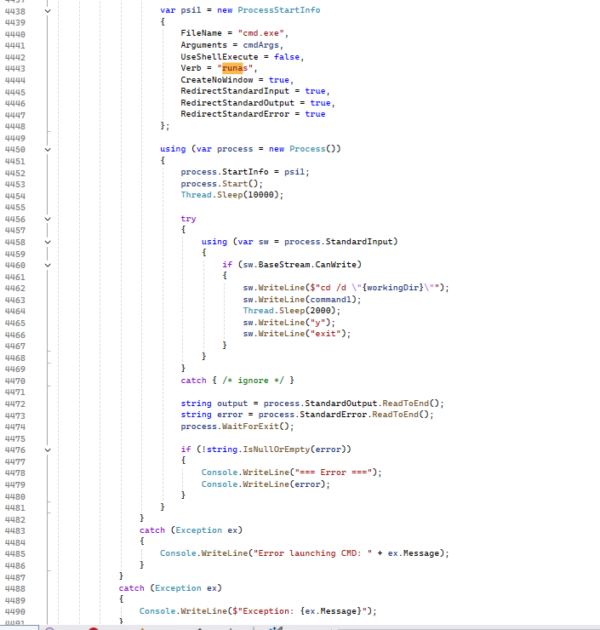
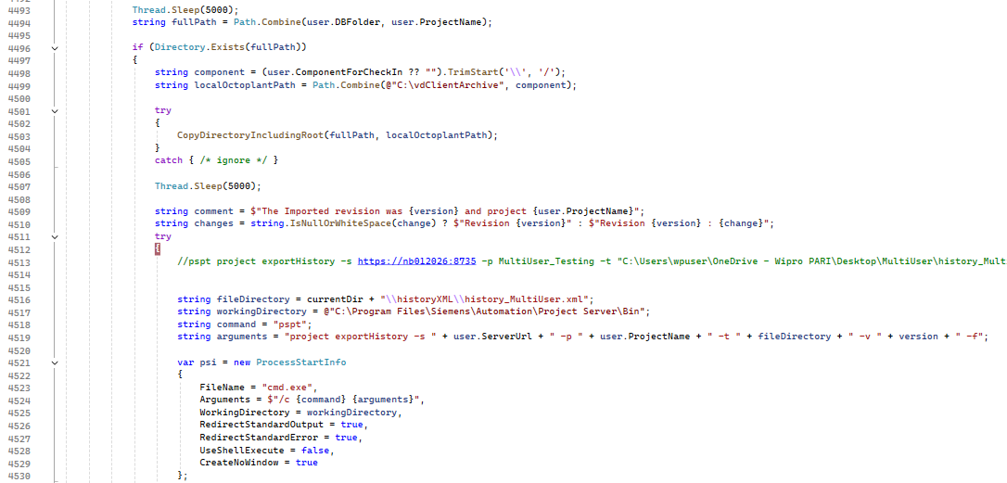
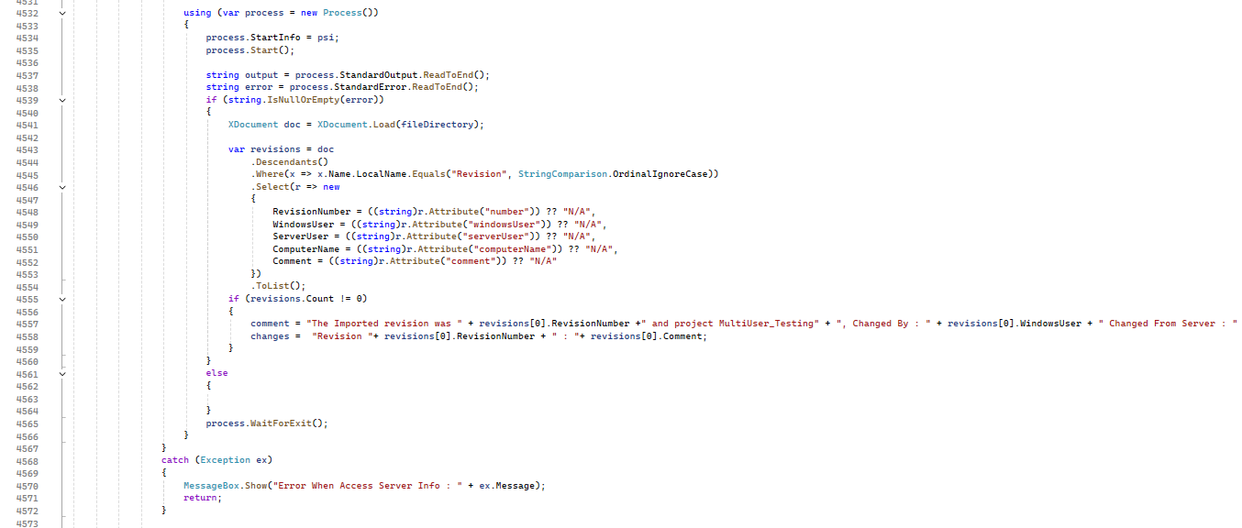
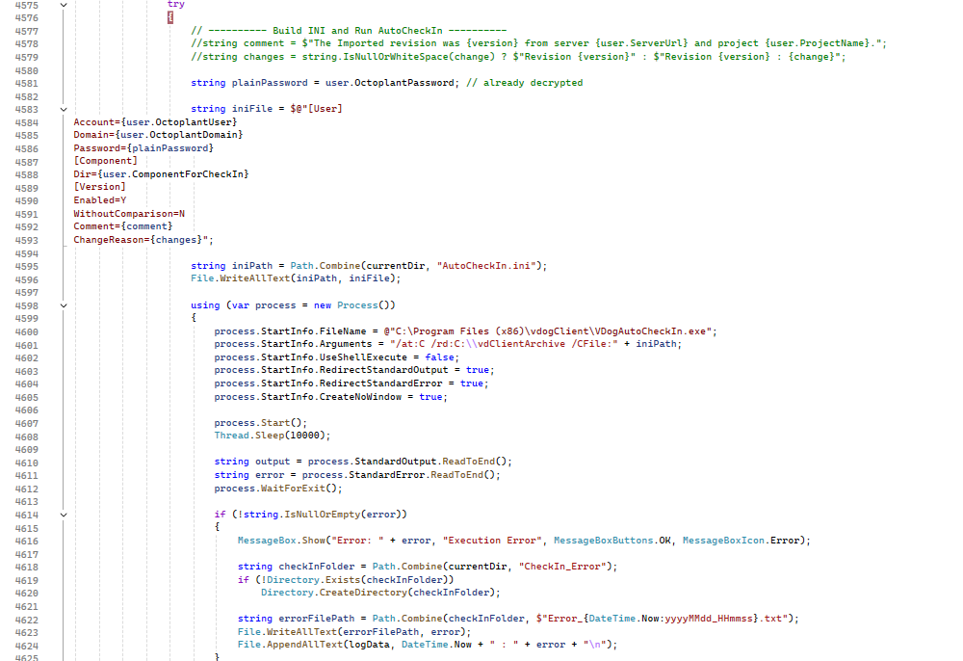
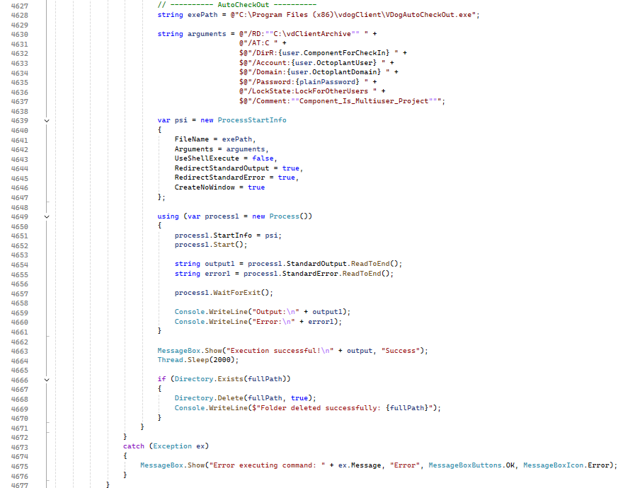
Description:
The RunAutomationCycle() method performs the main automation process that runs whenever the Start Service button is clicked.
It reloads the latest user configurations from the JSON file and processes each configured project in sequence.
For each project, the method:
- Fetches project details from the TIA Project Server using command-line (pspt checkin show).
Command : "checkin show --server " + user.ServerUrl + " --project " + user.ProjectName;
- Logs version and change information to a log file.
- Exports the project from the server (pspt project export) using command-line.
Command : "pspt project export --server {user.ServerUrl} --project {user.ProjectName} --path \"{exportPath}\" -v {version}";
- Copies the exported project folder to the Octoplant client archive directory.
- Generates an INI file and executes AutoCheckIn using VDogAutoCheckIn.exe.
Command : C:\Program Files (x86)\vdogClient\VDogAutoCheckIn.exe /at:c "/rd:{vdClientArchive}" [/account:] [/domain:] [/password:]
.INI file data :
[User]
Account={user.OctoplantUser}
Domain={user.OctoplantDomain}
Password={plainPassword}
[Component]
Dir={user.ComponentForCheckIn}
[Version]
Enabled=Y
WithoutComparison=N
Comment={comment}
ChangeReason={changes}
- Executes AutoCheckOut using VDogAutoCheckOut.exe to lock the component.
Arguments:
string arguments = @"/RD:""C:\vdClientArchive"" " +
@"/AT:C " +
$@"/DirR:{user.ComponentForCheckIn} " +
$@"/Account:{user.OctoplantUser} " +
$@"/Domain:{user.OctoplantDomain} " +
$@"/Password:{plainPassword} " +
@"/LockState:LockForOtherUsers " +
$@"/Comment:""Component_Is_Multiuser_Project""";
- Logs all actions and errors for review, then deletes the temporary project folder.
Result:
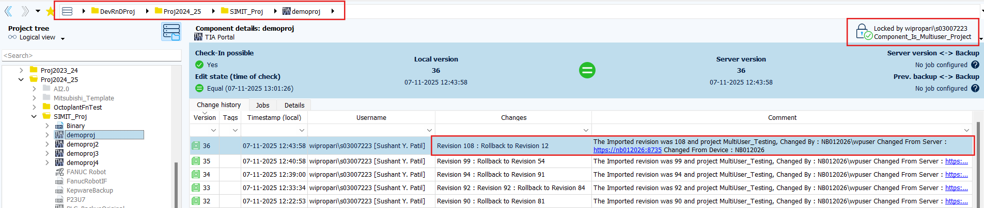
The updated project from the Project Server is successfully checked-in to Octoplant, with all changes and comments accurately carried over from the server project.

